|  |  |
| --- | --- |
| **­­­Exp No:1**  **Date: 7.2.25** | **HTML AND CSS** |

**AIM:**

To create a web page that embeds a map with hotspots, frames, and links using embedded, external, and inline CSS

**PROGRAM:**

**Hotspot.html**

<html>

<head>

<title>Map with Hotspots</title>

</head>

<body>

<h2>Image Map Example</h2>

<img src="india map.jpg" alt="Map" usemap="#workmap" width="600" height="400">

<map name="workmap">

<area shape="rect" coords="34,44,270,350" alt="Location1" href="https://www.google.com">

<area shape="circle" coords="337,300,44" alt="Location2" href="https://www.yahoo.com">

</map>

<br>

<a href="https://en.wikipedia.org/wiki/Outline_of_India">Visit Example</a>

</body>

</html>

**Style.css**

@charset*"ISO-8859-1"*;

**body**{

font-family:*Arial,sans-serif*;

margin:*0*;

padding:*0*;

background-color: *#f4f4f4*;

}

**img**{

display:*block*;

margin:*0auto*;

border-radius:*8px*;

box-shadow:*04px6pxrgba(0,0,0,0.1)*;

}

/* Styling for the map areas */

**area**{

outline:*none*;

border:*none*;

transition:*transform0.3sease-in-out*;

}

**area***:hover*{

transform:*scale(1.1)*;

}

**OUTPUT:**

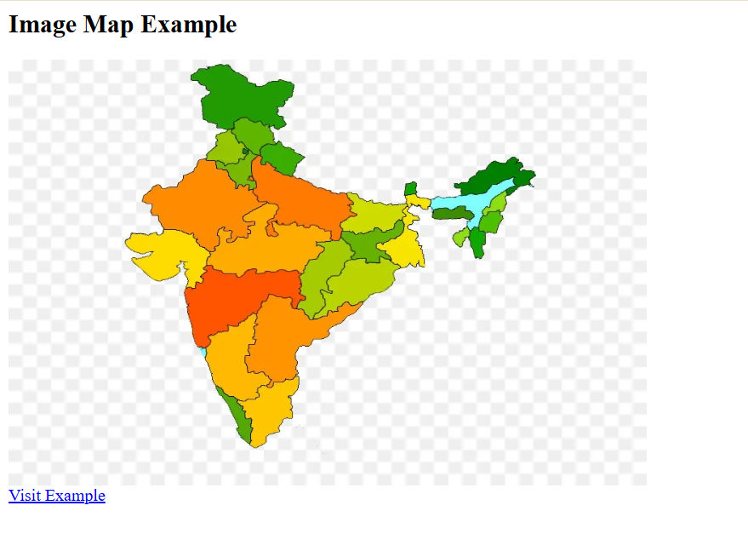

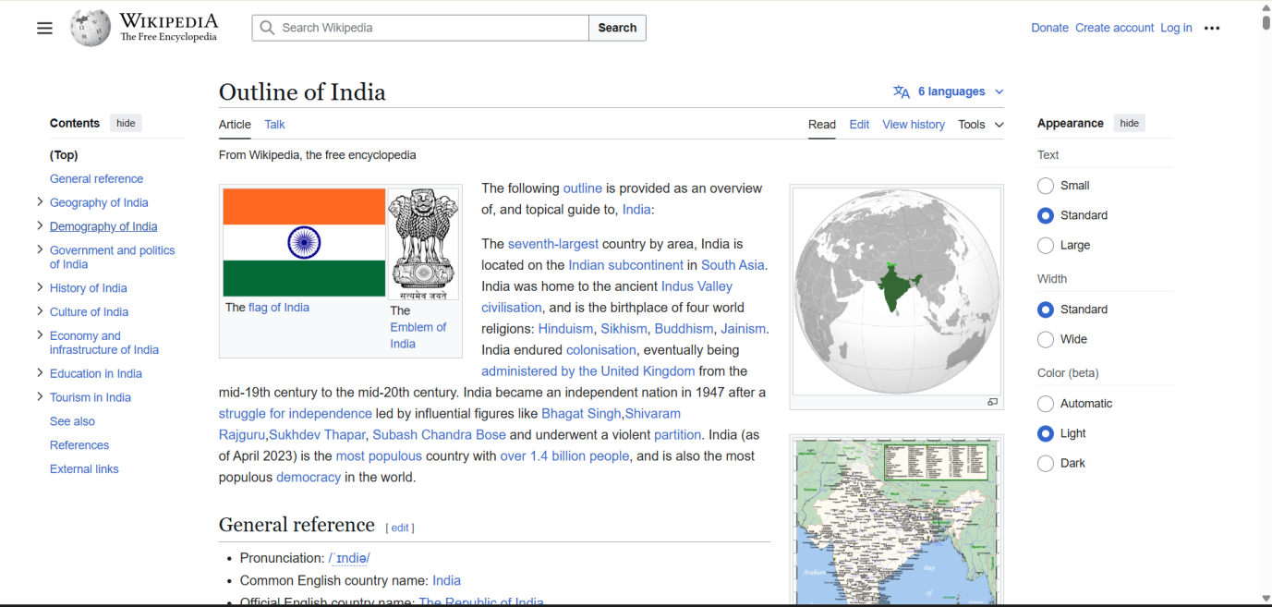

**RESULT :**Thus the experiment to create a web page that embeds a map with hotspots, frames, and links using embedded, external, and inline CSS has been successfully implemented and verified .